Obsolete figures



The TX77 sub-heatmap. - A/Bilthoven/2271/1976 and A/Texas/1/1977 are in the middle cluster - upper triangle = $\kappa=0.05$ and higher triangle=$\kappa=0.15

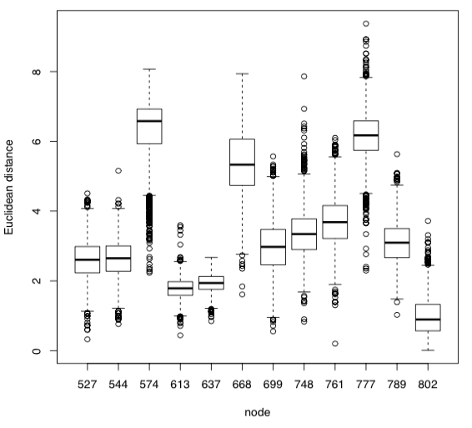

\caption{\textbf{Boxplot of the Euclidean distance of distribution of $\mu_i$, conditional on $I_i = 1$, from the parent clusters for the A/H3N2 analysis with $\kappa=0.05$}

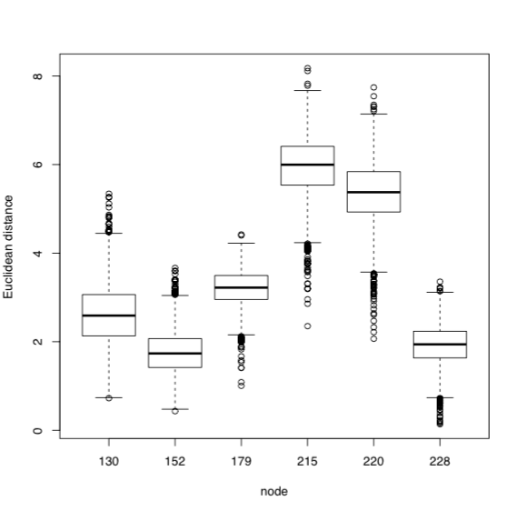

Boxplot of the Euclidean distance of distribution of $\mu_i$, conditional on $I_i = 1$, from the parent clusters for the A/H1N1 analysis with $\kappa=0.1$